LED String Animation

PO5_LSAN

**Software Requirements Specification Document**

Document status

|  |  |  |  |
| --- | --- | --- | --- |
| Version | Author | Date | Status |
| v1.1 | Sarah Abdelrahman | 21/02/2020 | proposed |

Document history

|  |  |  |  |
| --- | --- | --- | --- |
| Version | Author | Date | Change description |
| v.01 | Mohanad Sallam | 23/1/2020 | Create initial draft |
| v.02 | Mohanad Sallam  Sarah AbdelRahman | 29/01/2020 | Adding requirements |
| v.03 | Sarah Abdelrahman | 29/01/2020 | Adding requirements, System features and system interfaces |
| v.04 | Mohanad Sallam | 04/02/2020 | Removing Unused tittles,  Changing ID colors and Removing curly brackets |
| v.05 | Mohanad Sallam  Sarah AbdelRahman | 07/02/2020 | Updating requirements, System features and system interfaces |
| v.06 | Mohanad Sallam | 07/02/2020 | Update requirement 12 & 13, Removing system feature section. |
| v.07 | Mohanad Sallam | 12/02/2020 | Remove Requirement Description and updating Requirement tables. |
| v.08 | Mohanad Sallam | 15/02/2020 | Adding Reference Table |
| V1.0 | Sarah Abdelrahman | 21/02/2020 | Remove requirements from 004 to 010  Edit all requirements  Add new requirements from 018 to 021  Add software context  add software context sections |
| V1.1 | Sarah Abdelrahman | 21/2/2020 | Update requirement 011 |
| V1.2 | Sarah Abdelrahman | 26/2/2020 | Add requirement 022 |
| V1.3 | Sarah Abdelrahman | 1/3/2020 | -Change software context  - fix typo in req 022 and 002  -remove req 001 |

Contents

1.0 Introduction 3

1.1 Purpose 3

1.2 Project Description 3

1.3 Block diagram 3

2.0 The Overall Description 3

2.1 User Needs 3

2.2 Product perspective 3

2.2.1 System interfaces 3

2.2.2 Interfaces 3

3.0 Specific Requirements 4

3.1 Requirements Tables 4

3.2 Reference Documents 8

# Introduction

## Purpose

This is a v.02 of the requirements specifications for a LED String Animation.

## Project Description

This project consists of strings of LEDs in a certain pattern. The LEDs turn on/off based on input signals. The LEDs structure consists of two parts Tail and TI. Each Part will be activated according to the corresponding switches.

At Startup Mode there are two options (Modes):

First mode: LEDs shall turn-on from L6 to L1, then from R1 to R6 and vice versa, and then all LEDs are ON and OFF.

Second mode: LEDS from R1 to R6 are ON LED by LED and also the left branch at the same time, and then repeat the scenario again.

## Block diagram

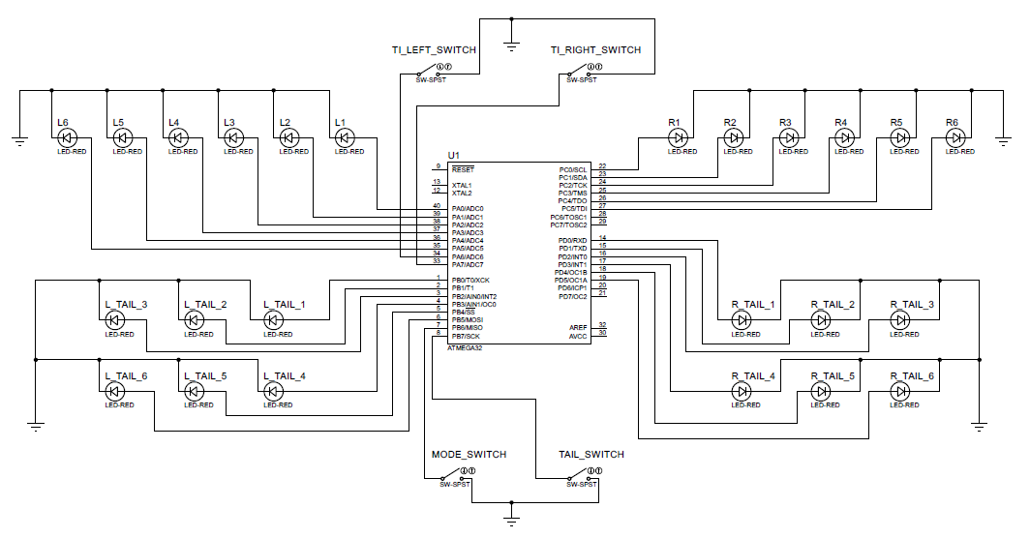

# 2.0 The Overall Description

## 2.1 User Needs

- Control the system through buttons

- Change the startup mode when needed

## 2.2 Product perspective

### 2.2.1 System interfaces

The system consists of 3 subsystems each has its own functionality:

1. Controls TI LEDs
2. Controls Tail LEDs
3. Sets the Startup mode

### 2.2.2 Interfaces

A unique signal is sent to the controller each controls one of the functionality.

# 3.0 Software context

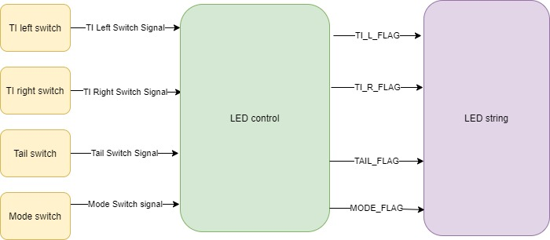

# 

# 4.0 Specific Requirements

## 4.1 Requirements Tables

### 4.1.1 Input features

We have no filtering feature

### 4.1.2 LED controller

|  |  |  |  |
| --- | --- | --- | --- |
| **Req ID** | Req _ PO5_SRS _ 022 _ v02 | | |
| **Covers** | Req_PO5_LSAN_HSI_001_V01 | **Test Scope** | ITD |
| **Input** | N/A | **Output** | N/A |
| **Author** | Sarah | **Date** | 26/02/2020 |
| **Description** | Initialize the following pins with the direction and initial values as stated   |  |  |  | | --- | --- | --- | | **PIN NUMBER** | **PIN DESCRIPTION** | **PIN DIRECTION** | | 1 | PB0 | O/P | | 2 | PB1 | O/P | | 3 | PB2 | O/P | | 4 | PB3 | O/P | | 5 | PB4 | O/P | | 6 | PB5 | O/P | | 7 | PB6 | I/P pull up | | 8 | PB7 | I/P pull up | | 14 | PD0 | O/P | | 15 | PD1 | O/P | | 16 | PD2 | O/P | | 17 | PD3 | O/P | | 18 | PD4 | O/P | | 19 | PD5 | O/P | | 20 | PD6 | O/P with initial value = 0 | | 21 | PD7 | O/P with initial value = 0 | | 22 | PC0 | O/P | | 23 | PC1 | O/P | | 24 | PC2 | O/P | | 25 | PC3 | O/P | | 26 | PC4 | O/P | | 27 | PC5 | O/P | | 28 | PC6 | O/P with initial value = 0 | | 29 | PC7 | O/P with initial value = 0 | | 33 | PA7 | I/P pull up | | 34 | PA6 | I/P pull up | | 35 | PA5 | O/P | | 36 | PA4 | O/P | | 37 | PA3 | O/P | | 38 | PA2 | O/P | | 39 | PA1 | O/P | | 40 | PA0 | O/P | | | |

|  |  |  |  |
| --- | --- | --- | --- |
| **Req ID** | Req _ PO5_SRS _ 022 _ v02 | | |
| **Covers** | Req_PO5_LSAN_HSI_001_V01 | **Test Scope** | ITD |
| **Input** | Mode Switch Signal | **Output** | N/A |
| **Author** | Sarah | **Date** | 1/03/2020 |
| **Description** | Software shall change MODE_FLAG to MODE-1 if the switch is on. | | |

|  |  |  |  |
| --- | --- | --- | --- |
| **Req ID** | Req _PO5_SRS _ 002 _ v02 | | |
| **Covers** | Req _PO5_CYRS _ 001 _ v01 | **Test Scope** | ITD |
| **Input** | Mode Switch Signal | **Output** | MODE_FLAG |
| **Author** | Sarah | **Date** | 1/03/2020 |
| **Description** | Software shall change MODE_FLAG to MODE-2 if the switch is off. | | |

|  |  |  |  |
| --- | --- | --- | --- |
| **Req ID** | Req _PO5_SRS _ 012 _ v02 | | |
| **Covers** | Req _PO5_CYRS _ 004 _ v01 | **Test Scope** | ITD |
| **Input** | Tail Switch Signal | **Output** | TAIL_FLAG status |
| **Author** | Sarah | **Date** | 21/02/2020 |
| **Description** | Software shall change TAIL_FLAG to TAIL_FLAG_ACTIVE when tail switch is pressed. | | |

|  |  |  |  |
| --- | --- | --- | --- |
| **Req ID** | Req _PO5_SRS _ 022 _ v01 | | |
| **Covers** | Req _PO5_CYRS _ 004 _ v01 | **Test Scope** | ITD |
| **Input** | Tail Switch Signal | **Output** | TAIL_FLAG status |
| **Author** | Sarah | **Date** | 21/02/2020 |
| **Description** | Software shall change TAIL_FLAG to TAIL_FLAG_DEACTIVE when tail switch is released. | | |

|  |  |  |  |
| --- | --- | --- | --- |
| **Req ID** | Req _PO5_SRS _ 019 _ v01 | | |
| **Covers** | Req _PO5_CYRS _ 005 _ v01 | **Test Scope** | ITD |
| **Input** | TI Right Switch Signal | **Output** | TI_R_FLAG status |
| **Author** | Sarah | **Date** | 21/02/2020 |
| **Description** | Software shall change TI_R_FLAG to TI_R_FLAG_ACTIVE when TI Right switch is pressed. | | |

|  |  |  |  |
| --- | --- | --- | --- |
| **Req ID** | Req _ PO5_SRS _ 015_ v03 | | |
| **Covers** | Req _ PO5_CYRS _ 005 _ v01 | **Test Scope** | ITD |
| **Input** | TI Right Switch Signal | **Output** | TI_R_FLAG status |
| **Author** | Sarah | **Date** | 21/02/2020 |
| **Description** | Software shall change TI_R_FLAG to TI_R_FLAG_DEACTIVE when TI Right switch is released. | | |

|  |  |  |  |
| --- | --- | --- | --- |
| **Req ID** | Req _PO5_SRS _ 020 _ v01 | | |
| **Covers** | Req _PO5_CYRS _ 005 _ v01 | **Test Scope** | ITD |
| **Input** | TI Left Switch Signal | **Output** | TI_L_FLAG status |
| **Author** | Sarah | **Date** | 21/02/2020 |
| **Description** | Software shall change TI_L_FLAG to TI_L_FLAG_ACTIVE when TI Left switch is pressed. | | |

|  |  |  |  |
| --- | --- | --- | --- |
| **Req ID** | Req _PO5_SRS _ 021 _ v01 | | |
| **Covers** | Req _PO5_CYRS _ 006 _ v01 | **Test Scope** | ITD |
| **Input** | TI Left Switch Signal | **Output** | TI_L_FLAG status |
| **Author** | Sarah | **Date** | 21/02/2020 |
| **Description** | Software shall change TI_L_FLAG to TI_L_FLAG_DEACTIVE when TI Left switch is released. | | |

### 4.1.3 Output feature

|  |  |  |  |
| --- | --- | --- | --- |
| **Req ID** | Req _PO5_SRS _ 003 _ v02 | | |
| **Covers** | Req _ PO5_CYRS _ 002 _ v01 | **Test Scope** | ITD |
| **Input** | MODE_FLAG is MODE_1 | **Output** | L LEDs sequence |
| **Author** | Sarah | **Date** | 21/02/2020 |
| **Description** | MODE_FLAG = MODE_1  Left leds sequence-1 activated  All left and right leds OFF  Right leds sequence-1 activated  **1200ms**  **2400ms**  **T = 0ms**  Left leds sequence-2 activated  All left and right leds OFF  All left and right leds ON  All left and right leds OFF  Right leds sequence-2 activated  **2600ms**  **3800ms**  **5500ms**  **5000ms**  **5200ms**  Right leds sequence-1:   1. R1 will only turn-on for 200ms. 2. R2 will only turn-on for 200ms. 3. R3 will only turn-on for 200ms. 4. R4 will only turn-on for 200ms. 5. R5 will only turn-on for 200ms. 6. R6 will only turn-on for 200ms.   Right leds sequence-2:   1. R6 will only turn-on for 200ms. 2. R5 will only turn-on for 200ms. 3. R4 will only turn-on for 200ms. 4. R3 will only turn-on for 200ms. 5. R2 will only turn-on for 200ms. 6. R1 will only turn-on for 200ms.   Left leds sequence-1:   1. L6 will only turn-on for 200ms. 2. L5 will only turn-on for 200ms. 3. L4 will only turn-on for 200ms. 4. L3 will only turn-on for 200ms. 5. L2 will only turn-on for 200ms. 6. L1 will only turn-on for 200ms.   Left leds sequence-2:   1. L1 will only turn-on for 200ms. 2. L2 will only turn-on for 200ms. 3. L3 will only turn-on for 200ms. 4. L4 will only turn-on for 200ms. 5. L5 will only turn-on for 200ms. 6. L6 will only turn-on for 200ms. | | |

|  |  |  |  |
| --- | --- | --- | --- |
| **Req ID** | Req _PO5_SRS _ 011 _ v02 | | |
| **Covers** | Req _PO5_CYRS _ 003 _ v01 | **Test Scope** | ITD |
| **Input** | MODE_FLAG is MODE_2 | **Output** | L LEDs and R LEDs sequence |
| **Author** | Sarah | **Date** | 21/02/2020 |
| **Description** | Software shall turn-on L LEDs in the following sequence 2 times:   1. L1 and R1 will only turn-on for 200ms. 2. L2 and R2 will only turn-on for 200ms. 3. L3 and R3 will only turn-on for 200ms. 4. L4 and R4 will only turn-on for 200ms. 5. L5 and R5 will only turn-on for 200ms. 6. L6 and R6 will only turn-on for 200ms. | | |

|  |  |  |  |
| --- | --- | --- | --- |
| **Req ID** | Req _ PO5_SRS _ 017_ v02 | | |
| **Covers** | Req _ PO5_CYRS _ 006 _ v01 | **Test Scope** | ITD |
| **Input** | TI_L_FLAG | **Output** | L LEDs status |
| **Author** | Sarah | **Date** | 21/02/2020 |
| **Description** | Software shall stop the pattern when the TI_L_FLAG is equal to TI_L_FLAG_DEACTIVE. | | |

|  |  |  |  |  |  |
| --- | --- | --- | --- | --- | --- |
| **Req ID** | Req _PO5_SRS _ 018 _ v01 | | | | |
| **Covers** | Req _PO5_CYRS _ 004 _ v01 | **Test Scope** | | ITD | |
| **Input** | TAIL_FLAG | **Output** | | Tail LEDs status | |
| **Author** | Sarah | **Date** | | 21/02/2020 | |
| **Description** | Software shall turn-on tail LEDs if TAIL_FLAG equal to TAIL_FLAG_ACTIVE. | | | | |
| **Req ID** | Req _PO5_SRS _ 013 _ v02 | | | | |
| **Covers** | Req _PO5_CYRS _ 004 _ v01 | **Test Scope** | | ITD | |
| **Input** | TAIL_FLAG | **Output** | | Tail LEDs status | |
| **Author** | Sarah | **Date** | | 21/02/2020 | |
| **Description** | Software shall turn-off tail LEDs if TAIL_FLAG equal to TAIL_FLAG_DEACTIVE. | | | | |
| **Req ID** | Req _ PO5_SRS _ 014_ v03 | | | | |
| **Covers** | Req _ PO5_CYRS _ 005 _ v01 | | **Test Scope** | | ITD |
| **Input** | TI_R_FLAG | | **Output** | | R LEDs status |
| **Author** | Sarah | | **Date** | | 21/02/2020 |
| **Description** | Software shall turn-on the R LEDs, if right TI_R_FLAG is equal to TI_R_FLAG_ACTIVE based on the following sequence:   1. R1 will only turn-on for 200ms. 2. R2 will only turn-on for 200ms. 3. R3 will only turn-on for 200ms. 4. R4 will only turn-on for 200ms. 5. R5 will only turn-on for 200ms. 6. R6 will only turn-on for 200ms. 7. Repeat. | | | | |

|  |  |  |  |
| --- | --- | --- | --- |
| **Req ID** | Req _ PO5_SRS _ 016 _ v03 | | |
| **Covers** | Req _ PO5_CYRS _ 006 _ v01 | **Test Scope** | ITD |
| **Input** | TI_L_FLAG | **Output** | L LEDs status |
| **Author** | Sarah | **Date** | 21/02/2020 |
| **Description** | Software shall turn-on the L LEDs, if right TI_L_FLAG is equal to TI_L_FLAG_ACTIVE based on the following sequence:   1. L1 will only turn-on for 200ms. 2. L2 will only turn-on for 200ms. 3. L3 will only turn-on for 200ms. 4. L4 will only turn-on for 200ms. 5. L5 will only turn-on for 200ms. 6. L6 will only turn-on for 200ms.   Repeat. | | |

## 4.2 Reference Documents

|  |  |  |  |
| --- | --- | --- | --- |
| **Reference Number** | **Document Name** | **Version** | **Status** |
| 1 | Req _ PO5_CYRS | 2.2 | Released |
| 2 | Req _ PO5_HSI | 1.5 | Released |